
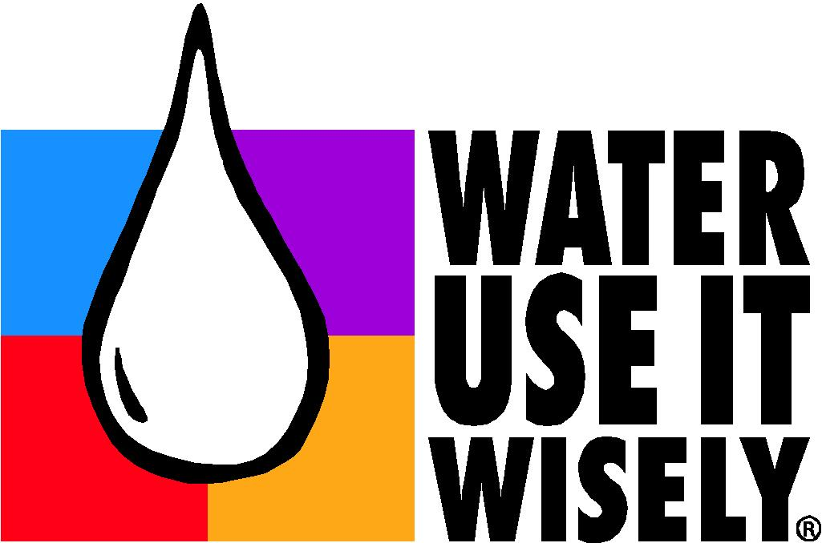
City of Whiteville, North Carolina
Water Shortage Response Plan

I. Purpose
A Water Shortage Response Plan is a useful tool in managing water supply problems and emergencies. This plan is to provide guidance to the Utilities Staff, City Manager, and customers of the Utilities Department during periods of drought and water supply disruption. It can also aid in response to manmade and natural disasters (acts of terrorism, contamination, floods, and hurricanes).The procedures herein are written to reduce potable water demand and supplement existing drinking water supplies whenever existing water supply sources are inadequate to meet current demands for potable water.

II. Authorization

The Whiteville City Manager shall enact the following water shortage response provisions whenever the trigger conditions outlined in Section VI are met. In his or her absence, the WWRF Director will assume this role.

Mr. Darren Currie
City Manager
Phone: (910) 642-8046
E-mail: dcurrie@ci.whiteville.nc.us
Mr. Nathan Guyton
City of Whiteville WWRF Director
Phone: (910) 642-5818
E-mail: nmccullen@ci.whiteville.nc.us

Some of the factors considered when determining if a water shortage exist are:

- Ability to maintain adequate water pressure in every portion of the water system for fire protection.
- Ability to re-fill water storage tanks of the water system.
- Adequacy of the water supply in terms of quantity for the foreseeable future to satisfy the anticipated demand.
- Conditions at the Well water intake.
- Drought declarations by the State of North Carolina.

III. Notification

The following notification methods will be used to inform water system employees and customers of a water shortage declaration: employee e-mail announcements, notices at municipal buildings, notices in water bills and on the City of Whiteville website homepage. Required water shortage response measures will be communicated through a local paper and other media outlets may be sought. Declaration of emergency water restrictions or water rationing will be communicated to all customers by telephone through reverse 911, unless it has become obsolete or it is not accessible.

IV. Priority Uses

Water use prioritization is the key to the success of a water shortage plan. By grouping water uses by category, the City of Whiteville can maintain service consistent with community values and priorities. All user/customer groups will be affected by the implementation of a water shortage response plan, but in a logical and progressive manner. This strategy allows decisions to be made when conditions change.

- Essential Water Use

Essential use means water necessary to maintain public health and safety.
All entities charged with ensuring those services are deemed essential
functions. In emergencies, water delivery may be limited to specific
locations.

Sample uses:
- Sustaining human & animal health and safety.
- Fighting fires.
- Testing for public safety standards.
- Continued operation of water system.
- Operation of medical care facilities.

- Community/Business Water Use

Community/Business use defines any use of water that is critical to the
function of a business or institution or has significant value to the
community.

Sample uses:
- Watering plant stock at nurseries, tree farms.
- Commercial car washing.
- Maintaining community pools.
- Agricultural applications.
- Drip irrigation/hand applied water to trees, plant beds.
- Water used in production of a product.

3.) Discretionary Water Use

Discretionary water includes water for activities that are deemed elective
or non-essential. These activities are the first to be regulated when
restrictive measures are enacted.

- Sample uses: Turf irrigation.
- Ornamental water use – fountains, decorative use.
- Water to fill or re-fill pools.
- Non-commercial car/vehicle washing.
- Irrigation during a rain event.
- Water applied to impervious surfaces – driveways.

V. Levels of Response

Five levels of water shortage response are outlined in the table below. The five levels of water shortage response are: voluntary reductions, mandatory reductions I and II, emergency reductions and water rationing. A detailed description of each response level and corresponding water reduction measures follow below.

Stage | Response | Description
D1 | Voluntary Reductions | Water users are encouraged to reduce their water use and improve water use efficiency; however, no penalties apply for noncompliance. Water supply conditions indicate a potential for shortage.
D2 | Mandatory Reductions I | Water users must abide required water use reduction and efficiency measures; penalties apply for noncompliance. Water supply conditions are significantly lower than the seasonal norm and water shortage conditions are expected to persist.
D3 | Mandatory Reductions II | Same as in Stage 2
D4 | Emergency Reductions | Water supply conditions are substantially diminished and pose an imminent threat to human health or environmental integrity.
D5 | Water Rationing | Water supply conditions are substantially diminished and remaining supplies must be allocated to preserve human health and environmental integrity.

In Stage D1, Voluntary Reductions, all water users will be asked to reduce their normal water use by 5%. Customer education and outreach programs will encourage water conservation and efficiency measures including: runoff and watering impervious surfaces; watering plants deeply to encourage root growth; washing only full loads in clothes and dishwashers; using spring-loaded nozzles on garden hoses; and identifying and repairing all water leaks.

In Stage D2, Mandatory Reductions I, all customers are expected to reduce their water use by 10% in comparison to their previous month’s water bill. In addition to continuing to encourage all voluntary reduction actions, the following restrictions apply: outdoor use of drinking water for washing impervious surfaces is prohibited; and all testing and training purposes requiring drinking water (e.g. fire protection) will be limited.

In Stage D3, Mandatory Reductions II, customers must continue actions from all previous stages and further reduce water use by 20% compared to their previous month’s water bill. All non-essential uses of drinking water are banned and garden and landscape irrigation must be reduced to the minimum amount necessary for survival.

In Stage D4, Emergency Reductions, customers must continue all actions from previous stages and further reduce their water use by 25% compared to their previous month’s water bill. A ban on all use of drinking water except to protect public health and safety is implemented. Additionally, in Stage 4, a drought surcharge of 1.5 times the normal water rate applies.

The goal of Stage D5, Water Rationing, is to provide drinking water to protect public health (e.g. residences, residential health care facilities and correctional facilities). In Stage D5, all customers are only permitted to use water at the minimum required for public health protection. Firefighting is the only allowable outdoor water use and pickup locations for distributing potable water will be announced according to Whiteville’s Emergency Response Plan. In Stage D5, drought surcharges increase to 3 times the normal water rate.

VI. Triggers

Trigger conditions that demonstrate worsening hydrologic conditions or increased water demand will define various stages of a water emergency. A summary of trigger conditions for various stages is provided in the table below.

Stage | Well Operating Conditions
*D1 | 20% reduction in seasonal normal distance from static water level and pump intake
*D2 | **Pumping Time >12 hrs, Monthly Average  40% reduction in distance from static water level and pump intake
*D3 | **Pumping Time >14 hrs , Weekly Average  60% reduction in distance from static water level and pump intake
*D4 | **Pumping Time >20 hrs, Weekly Average  80% reduction in distance from static water level and pump intake
*D5 | **Water level at pump intake elevation
- * NC Drought Monitor
- ** City of Whiteville Public Utility Water Production Trigger

VII. Enforcement

The provisions of the water shortage response plan will be enforced by the City of Whiteville Utility Department and police personnel. Citations are assessed according to the following schedule depending on the number of prior violations and current level of water shortage.

Water Shortage Level | First Violation | Second Violation | Third Violation
Voluntary Reductions  Stage D1 | N/A | N/A | N/A
Mandatory Reductions  (Stages D2 and D3) | Written  Warning | $250 | $500(or) 20% of the customers 12 month average bill whichever is greater & Discontinuation of Service
Emergency Reductions  Stage D4 | Written  Warning | $500 & Discontinuation of Service | $750(or) 20% of the customers 12 month average bill whichever is greater & Discontinuation of Service
Water Rationing  Stage D5 | Written  Warning | $750 & Discontinuation of Service | $1000(or) 20% of the customers 12 month average bill whichever is greater & Discontinuation of Service

When a violation is determined to have occurred, Personnel should:

- Confirm all appropriate meter and street address information.
- Write information on citation form.
- If customer is on-site, offer them conservation information and advise them of restrictions (verbal warning). Follow up with written warning.

The Utility Department shall have the authority to discontinue, or restrict water service to any person or structure in the event of a violation of the provisions of this plan during a Stage 2 or higher water shortage period. Prior to such termination, the Utility Supervisor shall give a written notice of intent to terminate. The utility customer shall have five (5) business days to request a hearing. The Utility Superintendent shall have five (5) business days to conduct the hearing as to why such termination should not be enforced. When a water service has been discontinued, it shall be a violation to reactivate such service without payment of appropriate penalties and/or service connection fees.

Drought surcharge rates are effective in Stages 4 and 5.
Reconnection fee will be 3 times the Current Standard Fee.

VIII. Public Comment

Customers will have an opportunity to comment on the provisions of the water shortage response plan. First, a brief statement will be published in The News Reporter providing customers with a Notice of Public Hearing and a link to the City of Whiteville’s website for review of the drafted plan. A Public Hearing will then be held to collect comments on the drafted plan. If required, the plan will be revised and then submitted to Whiteville City Council for final adoption.

IX. Variance Protocols

A variance from the prevailing mandatory water restrictions may be granted to a customer satisfying the requirements to use water for a purpose that would be otherwise prohibited. Variances may be granted if a customer or person demonstrates:

- That undue hardship would otherwise result.
- That there are no possible alternatives.
- That the applicant has taken and will take all reasonable measures to conserve water.

Applications for water use variance requests are available from the City of Whiteville website and City Hall. All applications must be submitted to the Utility Office for review by the City Manager or designee. A decision to approve or deny individual variance requests will be determined within five (5) business days of receipt of the request. If the request for a variance is denied, the property owner has the right to appeal the determination to City Council. City Council will hear the appeal at the next regularly scheduled meeting or at a special scheduled meeting provided the appeal request is received at least fourteen (14) days in advance of the next regular meeting.

X. Effectiveness

The effectiveness of the Whiteville water shortage response plan will be determined by comparing the stated water conservation goals with observed water use reduction data. Other factors to be considered include frequency of plan activation, any problem periods without activation, total number of violation citations, desired reductions attained and evaluation of demand reductions compared to the previous year’s seasonal data.

XI. Revision

The water shortage response plan will be reviewed and revised as needed to adapt to new circumstances affecting water supply and demand, following implementation of emergency restrictions, and at a minimum of every five years in conjunction with the updating of our Local Water Supply Plan. Further, a water shortage response planning work group will review procedures following each emergency or rationing stage to recommend any necessary improvements of the plan to Whiteville’s City Council. The City of Whiteville Utility Superintendent is responsible for initiating all subsequent revisions.

