
Water Shortage Response Plan
City of Marion, PWSID (NC 0156010)
JULY 1, 2025

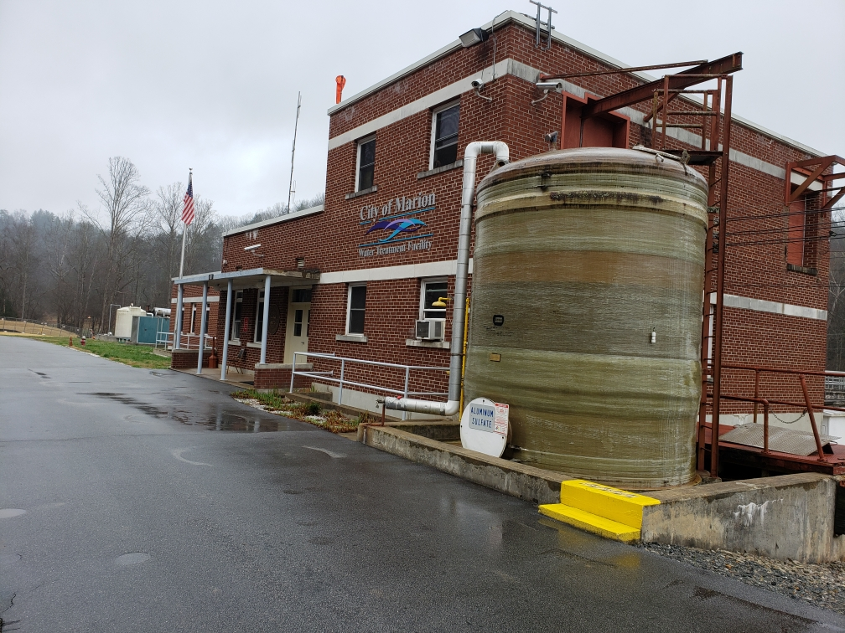
CITY OF MARION
WATER SHORTAGE RESPONSE PLAN

TABLE OF CONTENTS

SECTION Page

PURPOSE AND BACKGROUND 3

AUTHORIZATION 4

NOTIFICATION OF EMPLOYEES AND CUSTOMERS 5

WATER SHORTAGE RESPONSE PROGRAM 7

MANDATORY WATER SHORTAGE RESPONSE TRIGGERS 10

ENFORCEMENT 14

PROCEDURES FOR REVIEW AND APPROVAL OF VARIANCE REQUESTS 16

EXPECTED AND ACTUAL EFFECTIVENESS OF THIS PLAN 16

FUTURE REVIEW AND REVISION OF THE CITY’S WSRP 17

APPENDIX A – RESOLUTION APPROVING THE CITY OF MARION’S WATER SHORTAGE RESPONSE PLAN

SECTION 1.
PURPOSE AND BACKGROUND

This Water Shortage Response Plan (WSRP) describes the actions the City of Marion will take during a water shortage condition due to drought or special operational constraints, including the measures that the City will implement to reduce potable water use during such shortage conditions. This plan has been prepared as required by North Carolina General Statute (NCGS) 143-355(l).

That statute requires most public water systems in the State to have a State-approved WSRP as a component of their Local Water Supply Plan. State regulations governing water use during droughts and water emergencies (15A NCAC 02E .0607) and Session Law 2008-143 passed in July 2008 set forth specific items that must be included in local WSRPs.

The City of Marion’s WSRP is generally organized along the lines of the North Carolina Division of Water Resources’ (DWR) Water Shortage Response Plan (WSRP) Guidelines issued in January 2009. This plan meets the following criteria as required by the State, including:

- The designation of a staff position or organizational unit responsible for the implementation of their Water Shortage Response Plan;

- Notification procedures that will be used to inform employees and water users about the implementation of the plan and required water conservation response measures;

- Tiered levels of response actions to be taken to reduce water use based on the severity of water shortage conditions;

- Specific measurements of available water supply, water demand, and system conditions that will be used to determine the severity of water shortage conditions and to initiate water use reduction measures and the movement between various levels;

- Procedures that will be used to regulate compliance with the provisions of the plan;

- Procedures for affected parties to review and comment on the plan prior to final adoption;

- Procedures to receive and review requests for variances from specific requirements of the plan and the criteria that will be considered in the determination to issue a variance;

- An evaluation method to determine the actual water savings accomplished and the effectiveness of the Water Shortage Response Plan when implemented.

- Procedures for reviewing and revising the plan, which must be done at a minimum of every five years concurrent with the update of the state-required Local Water Supply Plan.

DWR is responsible for reviewing all WSRPs to ensure they meet the State’s minimum requirements.

SECTION 2.
AUTHORIZATION

The City of Marion’s City Manager is responsible for: (1) declaring a Water Shortage as described in this Plan; (2) enacting the applicable provisions of this WSRP; and (3) overseeing implementation of the Plan. In the City Manager’s absence, the Public Works Director is responsible for such actions.

As required by NCGS 143-355, the City of Marion will implement the provisions of this Plan whenever the trigger conditions established herein (and/or as they may be revised from time to time in accordance with Section 9 of this plan) occur.
Following is the contact information for the above-listed individuals as of the date of this plan: PRIMARY RESPONSIBILITY
Woody Ayers, or Successor
City Manager
City of Marion
PO Box 700
Marion, NC 28752

Telephone: 828-652-3551
E-Mail: wayers@marionnc.org

ALTERNATE
Brant Sikes, or Successor Public Works Director
City of Marion
PO Box 700
Marion, NC 28752

Telephone: 828-652-4224
E-Mail: bsikes@marionnc.org

SECTION 3.
NOTIFICATION OF EMPLOYEES AND CUSTOMERS

The City will, as soon as possible, notify its employees, customers, and the public if and when a Water Shortage declaration is issued as described in Sections 4 and 5. Such notification will be provided via several methods, including but not limited to the following:

- The City Manager (or designee) will notify the following officials and agencies:

  - City Council
  - Department Heads
  - Division of Water Resources and the Public Water Supply Section within the NC Department of Environmental Quality.

- The City Manager (or designee) will inform all city employees of changes in Water Shortage stages and conservation requirements applicable to the City of Marion’s customers. This will be communicated via one or more methods, including but not limited to:

  - e-mail through the City’s Local Area Network;
  - presentations at staff and crew meetings;
  - memoranda or other written materials.

Authorized Employees will be reminded of their role and responsibility and applicable procedures for monitoring and responding to potential or actual violations of applicable water use restrictions. If an authorized employee observes such an event, he/she will be instructed to attempt to inform the customer of the restrictions in effect, the observed violation, the need for corrective action by the customer, and consequences of repeat violations.

- The city’s Public Information Officer (or designee) will contact the news media (including newspapers and radio) and provide them with information about the applicable declaration, associated requirements, water rate surcharges if applicable, etc. Such notifications may be made by e-mail, website postings, news releases, telephone, social media, etc. News releases will include the name(s) and contact information of the city staff member(s) that will be primarily responsible for addressing media inquiries.

The city will make extensive use of e-mail, the media, and the city’s website, to provide information to its customers about the need to conserve water, the use restrictions in effect, and water rate surcharges if applicable.

- The Public Information Officer (or designee) will be responsible for updating the city’s website in a timely manner regarding current information on the status of local water supply and demands, Water Shortage declarations, conservation requirements, and water rate surcharges if applicable.

- The Public Information Officer (or designee) will be responsible for providing information about the water shortage on social media.

- The Public Information Officer (or designee) will assist city staff in responding to customer inquiries.

- If feasible, the city will notify residential and non-residential customers of water restrictions via media, telephone, and/or e-mail. In addition, city staff may provide targeted information to the following customers:

  - McDowell County, Nebo Water System
  - McDowell Hospital;
  - McDowell County School System;
  - McDowell Technical Community College
  - Marion Correctional Institution
  - Multi-family residential property owners/managers/residents;
  - Irrigation customers;
  - Hotels, carwashes, motels, and restaurants; and
  - Others as appropriate
SECTION 4.
WATER SHORTAGE RESPONSE PROGRAM

Water use prioritization is the key to the success of a water management plan. By classifying water uses, the City of Marion can maintain service consistent with community values and priorities. All users and customer groups will be affected by the implementation of a water shortage response plan, but in a logical and progressive manner. This strategy allows for decisions to be made when conditions change.

- Classification of Water Uses

A. Class I: Essential Water Uses

Domestic | Water necessary to sustain human life and the lives of domestic pets, and to maintain minimum standards of hygiene and sanitation.
Patient Care | Patient care and rehabilitation, including swimming pools used for patient care and rehabilitation.
Public Safety | Firefighting.  Certain testing and drills by the fire department if performed in the interest of public safety and if approved by the city manager.  Flushing of sewers and hydrants: As needed to ensure public health and safety and if approved by the city manager.

B. Class II: Socially or Economically Important Uses of Water

Domestic | All domestic uses other than those included in Classes 1 and 3.  Home water use including kitchen, bathroom and laundry use.  Minimal watering of vegetable gardens.  Watering of trees where necessary to preserve them.
Public Use | Filling and operation of public swimming pools. Watering of golf course greens.  Filling and operation of swimming pools and water parks:  Residential pools which serve more than twenty-five (25) dwelling units.  Pools or water parks operated by a governmental agency.
Commercial | Outdoor commercial watering (public or private) using conservation measures and to the extent that sources of water other than fresh water are not available to use.  Commercial car and truck washes.  Commercial laundromats.  Restaurants, clubs and eating places.
Agricultural | Irrigation for commercial vegetable gardens and fruit orchards or the maintenance of livestock.  Watering by commercial nurseries at a minimum level necessary to maintain stock.  Water use by arboretums and public gardens of national, state, or regional significance where necessary to preserve specimens.  Use of fresh water at a minimum rate necessary to implement vegetation following earth-moving, where such vegetation is required by law or regulation.
Industrial | Air conditioning:  Refilling for startup at the beginning of the cooling season.  Make-up of water during the cooling season.  Refilling specifically approved by health officials and the city manager, where the system has been drained for health protection or repair purposes.
Institutional | Schools, churches, motels/hotels and similar commercial establishments.

C. Class III: Non-Essential Uses of Potable Water

All | Ornamental purposes: Fountains, reflecting pools, and artificial waterfalls.  Outdoor noncommercial watering (public or private):  Gardens, lawns, parks, golf courses (except greens), playing fields and other recreational areas.  Filling and operation of recreational swimming pools which serve fewer than twenty-five (25) dwellings.  Noncommercial washing of motor vehicles.  Serving water in restaurants, clubs, or eating places except by specific request.  Air conditioning: refilling cooling towers after draining except as specified in Class 1.
Public Use | Fire hydrants: any purpose, including use of sprinkler caps and testing fire apparatus and for fire department drills, except as listed in Class 1.  Flushing of sewers and hydrants except as listed in Class 1.

- Levels of Response

Three stages of water shortage response are outlined in the table below. The three levels of water shortage response are: water shortage advisory (voluntary restrictions/reductions), water shortage alert (mandatory restriction/reductions) and water shortage emergency (escalated mandatory restrictions/reductions and water rationing). A detailed description of each response level and corresponding water reduction measures follow in table below.

Stage | Response | Action Description
1 | Water Shortage Advisory | The city manager or his designee shall regularly monitor the water supply and demands upon that supply. Whenever the city manager determines that a potential shortage of water supply is indicated, such that adequate potable water supplies cannot be maintained, whether the shortage is caused by drought, mechanical failure or limitations of water treatment plant capacity, he or she shall be empowered to declare a water shortage advisory and call upon all water customers to employ voluntary water conservation measures to limit water use (especially Class 3 uses) and eliminate the waste of water.
2 | Water Shortage  Alert | Whenever the City of Marion finds the raw water supply to be consistently below seasonal averages, and if the supply continues to decline it may not be adequate to meet normal needs, the city manager shall be empowered to declare a water shortage alert. The city shall continue to encourage voluntary water conservation measures defined under the voluntary conservation declaration, and further shall impose a ban on all Class 3 water uses for the duration of the shortage until it is declared to have ended by the city manager.
3 | Water Shortage Emergency | Whenever the City of Marion finds that raw water supplies are below the level necessary to meet normal needs and that serious shortages exist, the city manager shall be empowered to declare a water shortage emergency. Class 1, essential uses, shall be identified as targets for voluntary conservation initiatives. Also, all Class 2, socially or economically important uses, shall be banned in addition to the Class 3, nonessential uses. These restrictions shall continue until the emergency is declared ended by the city manager.

SECTION 5.
MANDATORY WATER SHORTAGE RESPONSE TRIGGERS

As required by NCGS 143-355, the City has established a set of specific measurements of available water supply and demand conditions to: assess the severity of water shortage conditions during extended droughts; guide the initiation of water use reduction measures; and guide the transition between the various water shortage stages described in this Plan. The measurements and rationale are explained below.

From time to time, it may be necessary to implement water use restrictions in response to certain drinking water system emergencies, such as water main breaks, water quality problems, planned and unplanned maintenance events, natural disasters, etc. The City of Marion’s water shortage response strategy for operational emergencies is also described below.

City staff continually monitors and evaluates the operational status of water supply, treatment, and distribution system components to ensure that customer demands can be met at any given time. Staff also tracks customer demands and the amount of raw water supply remaining in each of the three (3) supply sources, Buck Creek, Mackey Creek, and Clear Creek, on a daily basis. This and other information is used to guide the City’s water shortage response strategy.

- Intake Name and Capacity

NAME | MAX CAPACITY IN GPD | % OF SUPPLIED RAW WATER
Buck Creek | 2,649,600 | 69.2%
Mackey Creek | 767,520 | 20%
Clear Creek | 413,280 | 10.8%

Triggers for Implementing Water Shortage Response Stages During Extended Droughts

The City of Marion’s three (3) raw water intakes are very primitive in design. Simple water level benchmark gauges have been set up on the weir spill areas at Mackey and Clear Creek intakes. Buck Creek intake water supply is gauged by benchmark levels at the Lake Tahoma Dam, just upstream of the intake. Each stage trigger is explained in the table below.

Condition at 2 water intakes and Lake Tahoma Dam | Normal | Stage 1 Advisory | Stage 2 Alert | Stage 3 Emergency
Weir spill area and Dam > Advisory benchmark |  | X | X | X
Weir spill area and Dam < Advisory benchmark for three (3) consecutive days | X |  | X | X
Weir spill area and Dam < Alert benchmark for three (3) consecutive days | X | X |  | X
Weir spill area and Dam < emergency benchmark for three (3) consecutive days | X | X | X

Triggers for Rescinding Water Shortage Response Stages During Extended Droughts

For a Water Shortage stage to be rescinded, the water supply storage volume must be at or above the specified Water Shortage initiation trigger for the applicable stage for 3 consecutive days. However, the City Manager may delay the rescission of a Water Shortage stage depending on water supply and demand conditions, extended weather forecast, regional water supply conditions and outlook, and other factors.

As with initiation, rescission of Water Shortage stages may not always occur sequentially, depending on how quickly supply and/or demand conditions change.

Water Shortage Response Triggers for Operational Emergencies

The City of Marion may occasionally need to implement mandatory water use restriction to address abnormal operating conditions – other than extended droughts – when current demand cannot be met. Such events include, but are not limited to:

  - production problems at the City of Marion Water Treatment Plant;
  - pump, tank, or pipeline failures;
  - raw or treated drinking water quality problems;
  - planned or unplanned maintenance events; and
  - natural disasters.

Operational emergencies are typically characterized by the need for rapid response by City staff and its customers and may require major curtailment of water use in a short period of time. Non-drought water emergencies are unique because of the potential lack of preparation time and the need for immediate and potentially large-scale demand reductions. Because each emergency scenario is different, no single strategy can meet the City’s needs during all emergency scenarios.

Thus, the City Manager may implement a Water Shortage response stage and associated mandatory water use restriction that he/she deems necessary and appropriate given the nature, extent, and expected duration of the emergency condition. The stage and duration of such a Water Supply Shortage or Emergency shall be guided by the degree to which customer demands approach or exceed the City’s capacity to meet those demands, and by the degree to which conservation efforts successfully reduce short-term demands.

The Water Shortage response stage initially selected may be quickly modified as operating conditions are further assessed and there is a better understanding of the length of time that may be needed to restore normal operating and/or demand conditions.

Because Buck Creek intake provides the majority of raw water to the City, it’s operational function will play a vital role in determining any water shortage declarations. In the event that Buck Creek intake has become inoperable, the City has set the following triggers.

- Buck Creek intake inoperable for 24 hours, the City shall declare a water shortage advisory.
- Buck Creek intake inoperable for 48 hours or more, the City shall declare a water shortage alert.
- Buck Creek intake inoperable for 72 hours or more, the City shall declare a water shortage emergency

SECTION 6.
ENFORCEMENT AND PENALTIES

- The direct or indirect use of water from the City of Marion distribution system in violation of this article is prohibited. Any water customer of the City of Marion distribution system that violates or permits the violation of section 4 of this plan shall be subject to a penalty of up to five hundred dollars ($500.00). The penalty described in this section may be assessed before or after any notice required has been issued.
- Each violation shall be added to the customer's water bill and paid in the same manner as current payments to the City of Marion.
- Each day a violation occurs shall be considered a separate violation.
- If a violation is known to have occurred pursuant to this section, a written notice shall be mailed to the customer of record and to any other person known to the City of Marion who is responsible for the violation and its correction, or affixed to the property. The written notice shall describe the violation and order that it be corrected immediately or within such specified time as the City of Marion determines is reasonable under the circumstances. The penalty described in subsection (1) above applies whether or not a notice is issued under this subsection.
- If the notice is not complied with, the City of Marion may terminate water service to the customer subject to the following procedure:
- The city shall give the customer notice by mail that, due to the violation, water services will be discontinued within a specified time and that the customer will have the opportunity to appeal the termination by requesting in writing a hearing scheduled before the city council within seven (7) days of receipt of the notice.
- In the event of an Emergency Water Shortage, the City of Marion reserves the right to terminate water service immediately to any customer found to be in violation of Section 4 of this plan.
- If such a hearing is requested by the customer charged with the violation, he or she shall be given a full opportunity to be heard before termination is ordered.
- The city council shall make findings of fact and order whether water service should be continued or terminated.
- A connection fee shall be paid for the reconnection of any water service restricted or terminated. In the event of subsequent violations, the reconnection fee shall be doubled for the second violation and tripled for each additional violation.

Water Shortage Level | First Violation | Second Violation | Third Violation
Advisory | N/A | N/A | N/A
Alert | Warning | $250 | Discontinuation of Service
Emergency | $500 | Discontinuation of Service | Discontinuation of Service

Shortage water rates.

Upon the declaration of a water shortage advisory, water shortage alert or water shortage emergency, the city council of the City of Marion shall have the power to adopt shortage water rates by ordinance designed to conserve water supplies. Such rates may provide for, but not be limited to:
  - Higher charges per unit for increasing usage (increasing block rates);
  - Uniform charges for water usage per unit of use (uniform unit rate);
  - Extra charges for use in excess of a specified level (excess demand surcharge); or
  - Discounts for conserving water beyond specific levels.

SECTION 7.
PROCEDURES FOR REVIEW OF VARIANCE REQUESTS

Customers may request a variance from the Water Conservation Standards by submitting a letter or e-mail to The City Manager (or designee) specifically describing the nature and reason for the requested variance and the customer’s specific plan to reduce water use or to maintain a high level of water use efficiency during the declared shortage.

A decision to approve or deny individual variance requests will be provided to the customer within two weeks of receipt of the request, after careful consideration of the following criteria:

- purpose and necessity for use of drinking water;
- social and economic importance/hardship imposed by compliance with the Standards;
- the prevention of structural damage impact;
- expected duration of the use for which the variance is requested;
- expected direct and indirect impact on water demands; and
- practicality of options for alternative water sources.

SECTION 8.
EXPECTED AND ACTUAL EFFECTIVENESS OF THIS PLAN

The effectiveness of the City’s water shortage response plan will be determined by comparing the stated water conservation goals with observed water use reduction data. Other factors to be considered include frequency of plan activation, any problem periods without activation, total number of violation citations, desired reductions attained and evaluation of demand reductions compared to the previous year’s seasonal data.

The City has the following water use reduction objectives associated with the Water Shortage Response Stages in the Standards:

Expected/Targeted Water Use Reductions for the City’s Water Shortage Stages

Water Shortage Response Stage | Target Reductions Relative to Normal* Water Use
Stage 1 Advisory | 10%
Stage 2 Alert | 20%
Stage 3 Emergency | 30% +

- Normal Water Use is the level of customer demands that would be expected to occur during the time of the year that the Water Shortage Response Stage is in effect.

The City will periodically evaluate the effectiveness of its Water Shortage response actions through several methods, including but not limited to:

  - comparing actual demand reductions achieved to the objectives of the Water Conservation Standards, as well as demand information for the same period for prior years;

  - monitoring the frequency, severity, and duration of declared Water Shortage conditions;

  - identifying any situations where action should have been taken but was not required under this plan;

  - monitoring the number, type and recurrence of violations of applicable water use restrictions, and any required enforcement actions; and

  - reviewing the inquiries and feedback received from customers during declared Water Shortages.

SECTION 9.

FUTURE REVIEW AND REVISION OF THE CITY’S WSRP

In accordance with State requirements, the City of Marion will review the local WSRP, and revise it where necessary, as follows:

  - concurrent with the update of the City’s Local Water Supply Plan as required per NCGS 143-355(l), which occurs a minimum of once every five years;
  - following the rescission of all mandatory water use restrictions that were imposed during an event that required declaration of a Stage 1, Stage 2, or Stage 3 Water Shortage condition; and/or
  - at any time as deemed necessary to reflect changes in water supply and demand conditions, new information regarding the effectiveness of conservation management practices including the water use restrictions in the City’s Water Conservation Standards, experience gained with implementation of the plan, and other factors.

The City Manager (or designee) will be responsible for initiating all major WSRP updates, and for ensuring that customers and the public have the opportunity to comment on the plan and any proposed changes prior to final approval by the City Council.

APPENDIX A
RESOLUTION APPROVING CITY OF MARION’S WATER SHORTAGE RESPONSE PLAN

