Water System: Bayleaf/Leesville Master PWSID: 03-92-373

WATER SHORTAGE RESPONSE PLAN (WSRP)
FOR
Aqua North Carolina, Inc (Aqua)

As an investor-owned public utility, Aqua North Carolina, Inc. (Aqua) is regulated by the North Carolina Utilities Commission (NCUC). In addition to abiding by the provisions and orders established and issued by the NCUC regarding restrictions for nonessential water usage, Aqua will manage its drinking water supply and demand.

- Responsibilities: Upon issuance of orders concerning restrictions for nonessential water usage by the NCUC, Aqua’s President will serve as primary authority responsible for implementing all water shortage response protocols.
  - President: Shannon V. Becker, 919-653-5770, email: svbecker@aquaamerica.com
  - In the absence of the President, the following individuals are designated with the authority to implement the plan:
    - Chief of Operations and Engineering: Joseph Pearce, P.E. 919-653-6964, email: jrpearce@aquaamerica.com
    - Director, Environmental Compliance: Amanda Berger 910-773-0406; aaberger@aquaamerica.com

- Notification Procedures: The following methods may be utilized by the President (or his designee) to inform water users and system employees when water shortage response protocols are implemented and of the required response measures:

- The NCUC order may be issued via Press Release or mail to water customers in the corresponding awareness area(s)

- All employees will be notified by company-wide e-mail. E-mail(s) will include, at a minimum, a copy of the NCUC order, and detailed instructions of the protocol established for implementing the order.

- Determination of Severity, Implementation Criteria, and Levels of Response: On May 23, 2008, an “Order Modifying Restrictions Concerning Nonessential Water Usage…” (See Attachment 3) as issued which eased the previous restrictions and established water conservation levels of response based upon the drought severity classification as determined by the North Carolina Drought Management Advisory Council (NCDMAC). The Drought Severity Classifications are defined as:

  - Stage I Normal Conditions (NO) – Voluntary, Odd/Even Irrigation
  - Stage II Abnormally Dry (D0) – Mandatory, Odd/Even Irrigation allowed 3 days/week
  - Stage III Moderate Drought (D1) – Mandatory, Odd/Even Irrigation allowed 2 days/week
  - Stage IV Severe Drought (D2) – Mandatory, Odd/Even Irrigation allowed 2 days/week
  - Stage V Extreme Drought (D3) – Mandatory, Odd/Even Irrigation allowed 1 day/week
  - Stage VI Exceptional Drought (D4) – No spray irrigation allowed

As a private utility, Aqua is required to adopt the levels of response as established by the NCUC order. As necessary, Aqua will revise our plan in accordance with any subsequent revisions to the Order.

EXCEPTIONS & CLARIFICATIONS

  - Purchased Water Systems: In the case where Aqua purchases for the purpose of re-sale, the Order specifies that these systems “will be subject to the same water restrictions that are imposed by their local municipality that supplies their utility provider with water.” (See Attachment 3, Page 2, Item 1). For a list of these systems, see Attachment 4, “Purchased Water Suppliers”.

B. Special Conditions: As deemed necessary by specific system conditions Aqua may ask the NCUC to allow stricter restrictions on a system by system basis.

- Enforcement Provisions: In accordance with Item 4 of the May 23, 2008 Order (See Attachment 3, Page 6, Item 4), “…a regulated water company should be allowed to disconnect a water customer if he or she violates the restrictions set out in this Order. However, a customer must be provided a 24-hour notice prior to disconnection (for this purpose a door hanger type notice will be sufficient). The customer will have a full business day after the date of notification to show cause why his or her service should not be disconnected and should contact the Operations Division of the Commission by telephone at (919) 733-3979. If the customer does not successfully show cause, the utility may disconnect service at the end of the next business day. The utility shall immediately notify the Commission when it disconnects a customer’s service for violation of these nonessential water usage restrictions.” Aqua-North Carolina, Inc. is listed with the authority to enforce the provisions outlined by the May 23, 2008 order issued by the North Carolina Utilities Commission.

- Customer Review & Comment: On May 1, 2008, the NCUC issued an “Order Requesting Comments” which gave water users and water suppliers the opportunity to provide comments for the modification of the October 24, 2007 water usage restrictions. According to the NCUC, these comments were taken into consideration and incorporated into the May 23, 2008 revision to the Order.

- Variance Considerations: The NCUC will consider exceptions to the restrictions on an individual basis in accordance with Item 5 of the October 24, 2007 order (See Attachment 2, Page 3, Item 5). “Those desiring an exception shall send a written statement to the Commission outlining the reason(s) that they should be excluded from this restriction.”

- Measurement of Success: Effectiveness of the water shortage response protocols will be evaluated on a statewide basis by the DMAC. Aqua will continue to closely monitor the water usage in our systems.

- Revisions to Protocol: In accordance with the May 23, 2008 NCUC Order, revisions to drought response actions are dependant upon the DMAC drought severity classification for a particular area. “The level of restrictions applicable to a particular county will vary as the DMAC drought severity map classifications change from week to week every Thursday. For this purpose, the official drought severity classification for each county will be designated in accordance with DMAC’s placement of each county in its listing for “Counties Under Current Advisory. The entire county is designated under a single classification which is based upon the highest level of drought severity applicable to any portion of the county in questions.” ” (See Attachment 3, Page 3, Item 3). Under the order issued by the North Carolina Utilities Commission on May 23, 2008, water reduction measures, or triggers, are based on the DMAC drought severity map.

- Water Impoundment Owned by Others: In those systems where the water supply and storage facilities are not owned or controlled by Aqua. (See Attachment 4 Purchase Water Suppliers), the Water Shortage Response procedures shall be in accordance with the protocol established by the water supplier. See Item III.A., above and Attachment 3, Page 2, Item 1 for NCUC clarification.

- Revisions: The water shortage response plan will be reviewed and revised as needed to adapt to new circumstances affecting water supply and demand, following implementation of emergency restrictions, and at a minimum of every five years in conjunction with the updating of our Local Water Supply Plan and any revisions to the NCUC order issued on May 23, 2008. Further a water shortage response planning work group will review procedures following each emergency or rationing stated to recommend any necessary improvements to the Plan for Bayleaf Master System. The Manager of Environmental Compliance is responsible for initiating all plan reviews and revisions.

ATTACHMENT 2
(October 24, 2007 NCUC Order)

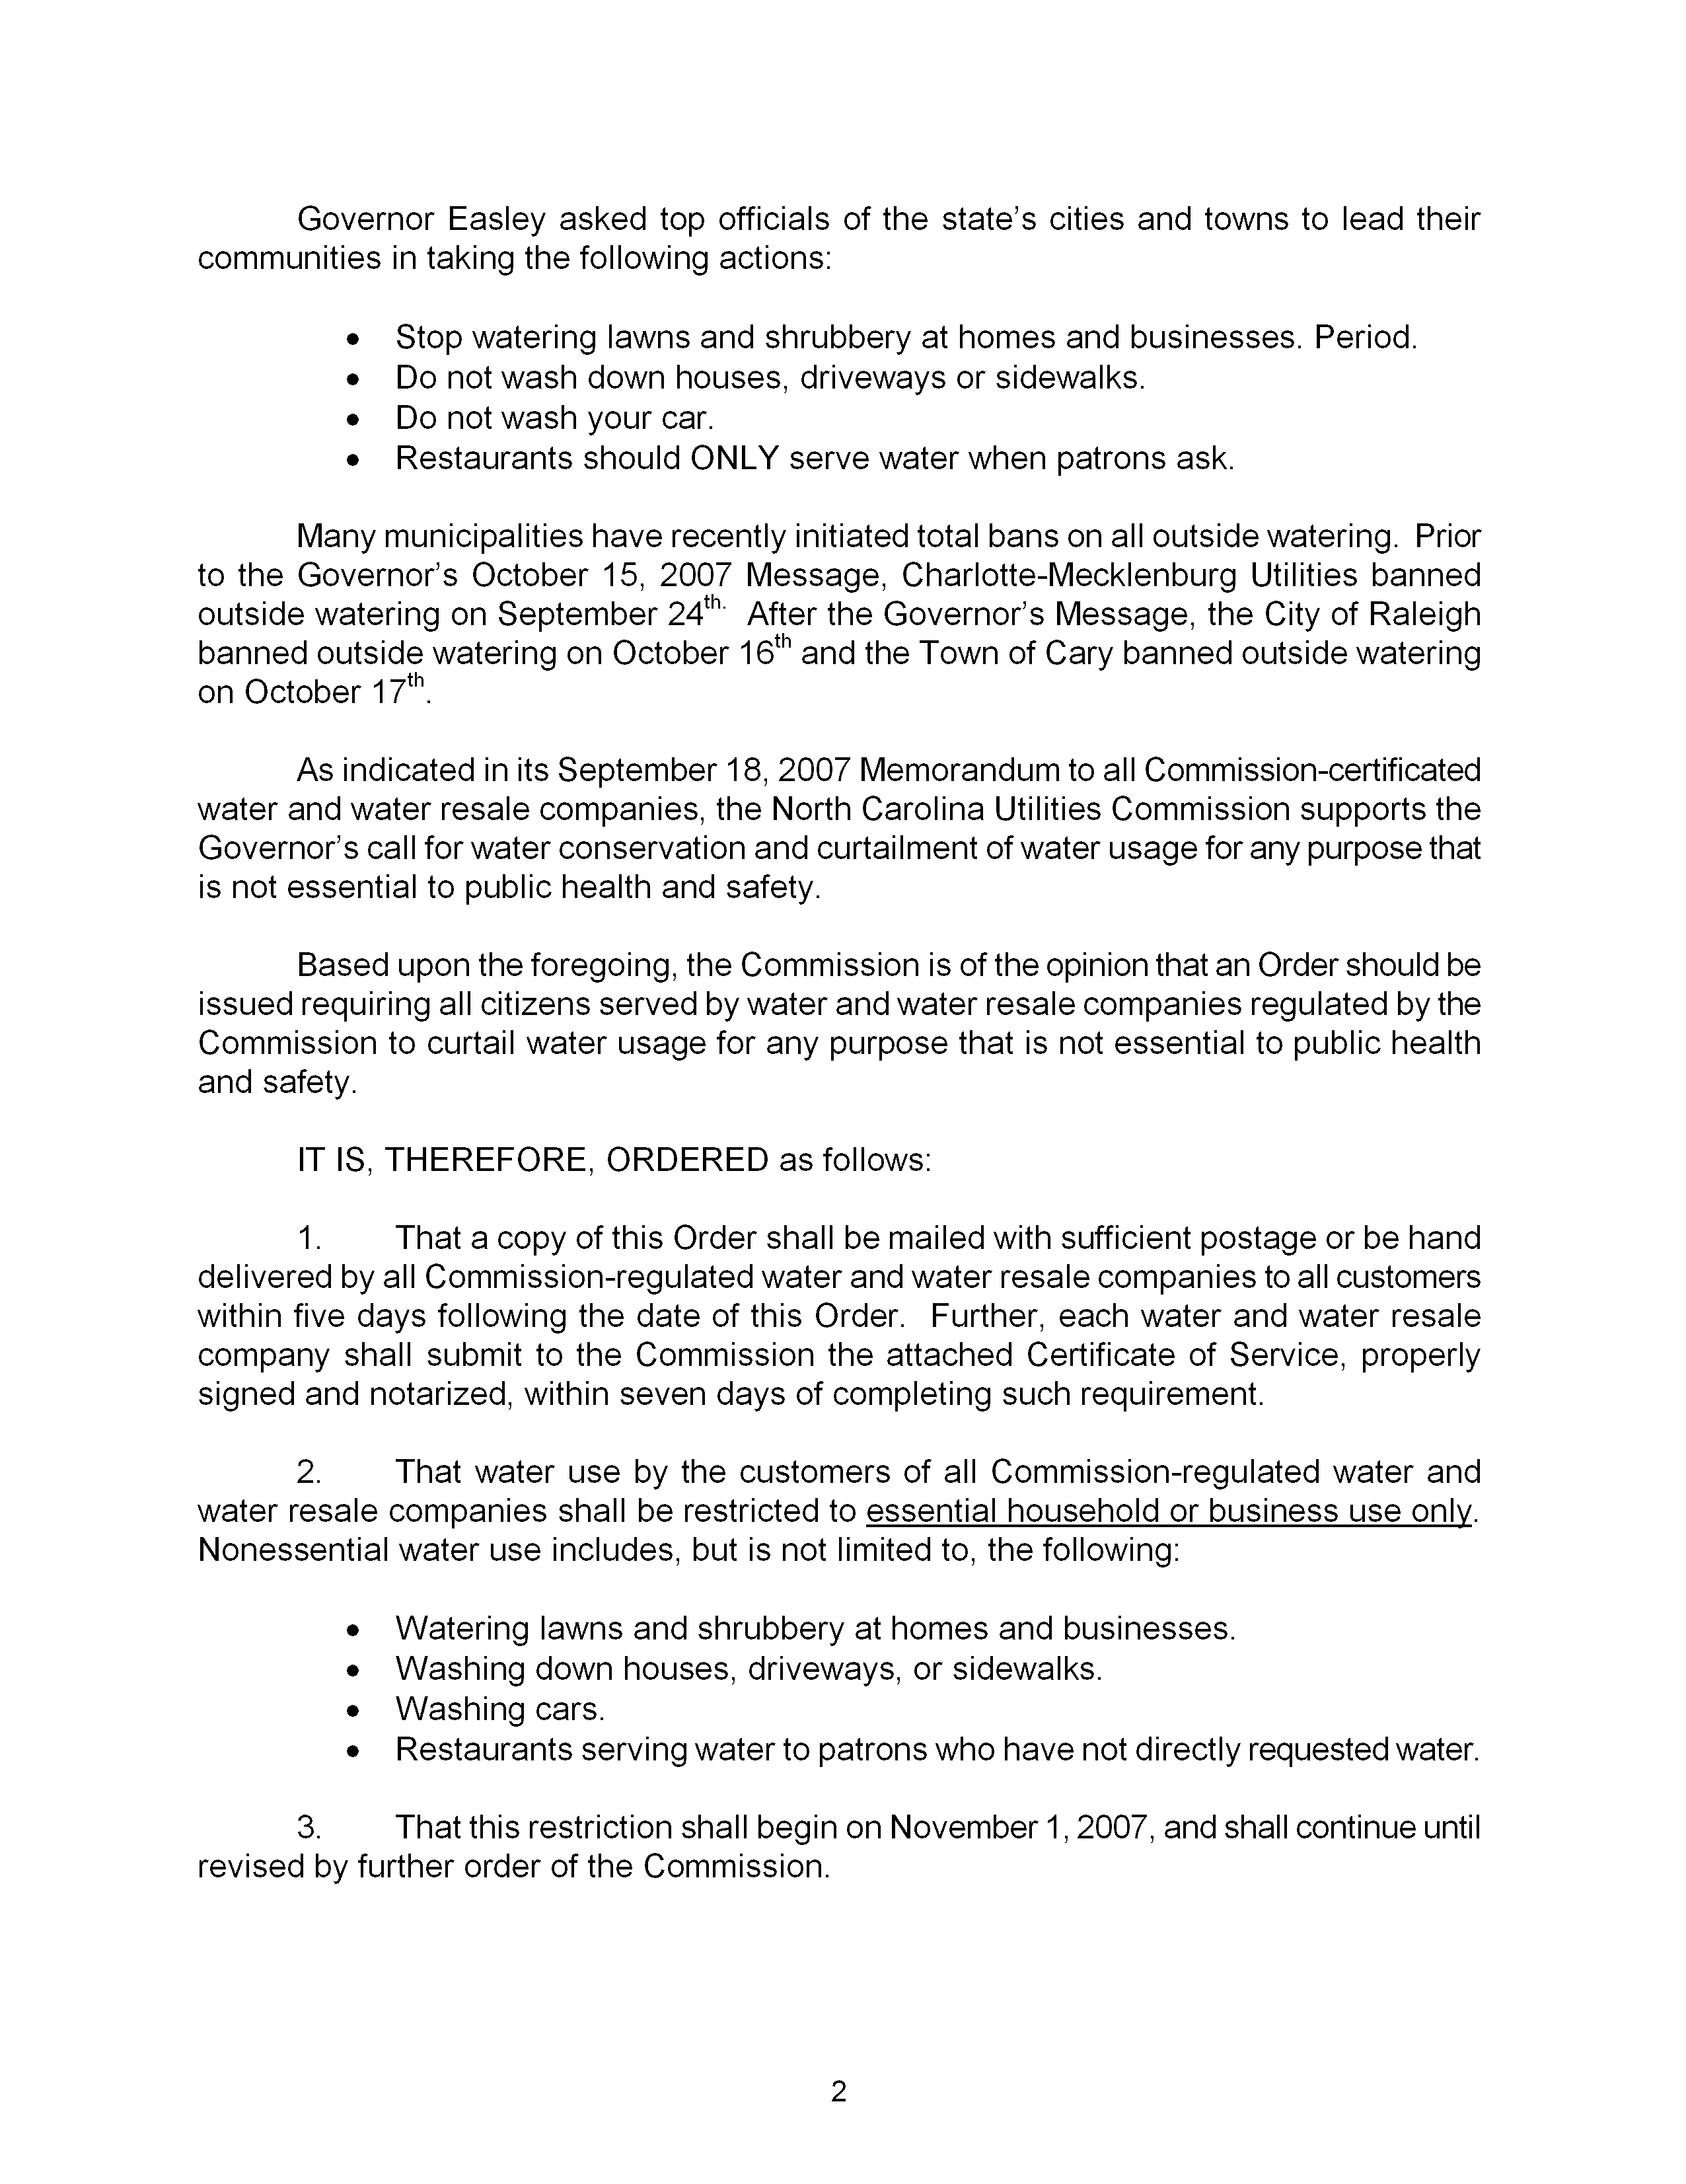
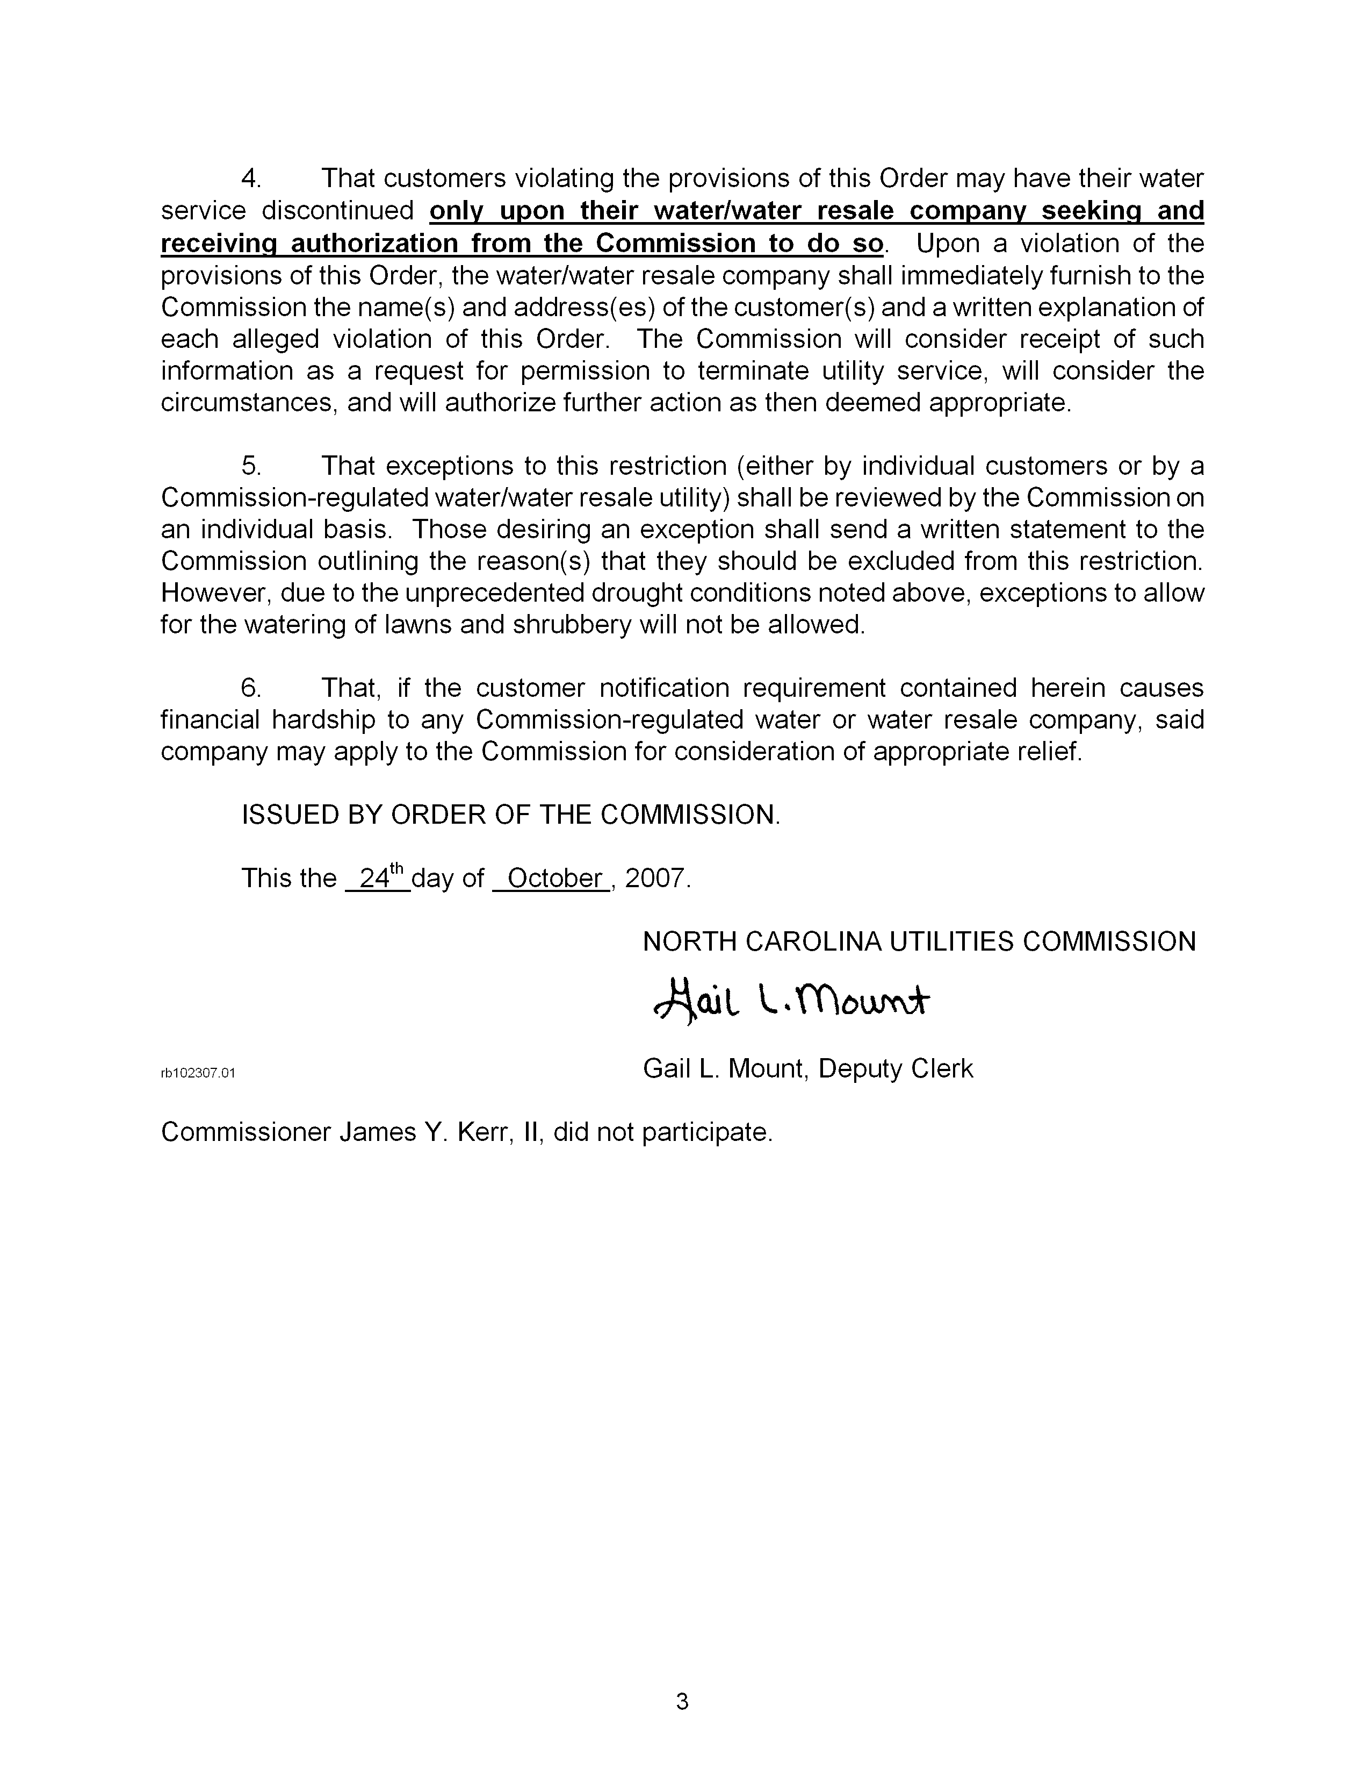

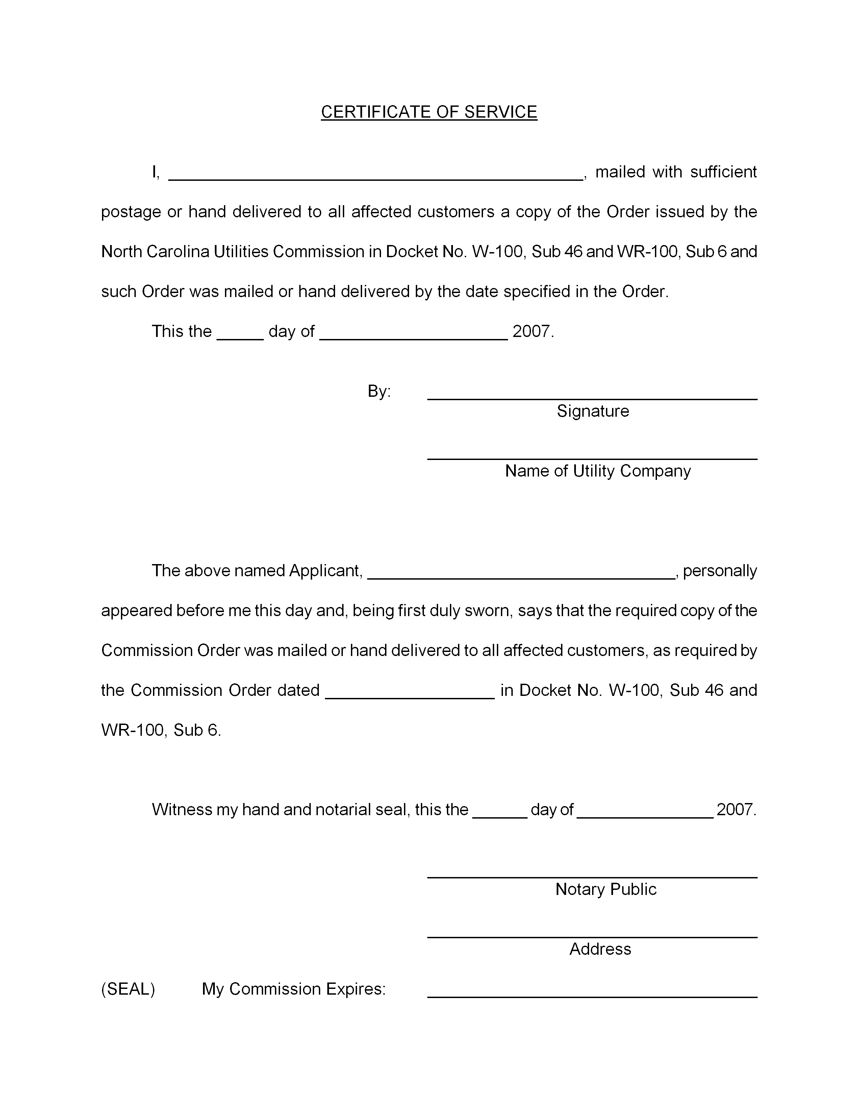

ATTACHMENT 3
(May 23 2008 NCUC Order)

ATTACHMENT 4
(Purchase Water Suppliers)

