# Adopted by Newton City Council on August 21, 2007 Amended on October 16, 2007

**Amended on May 6, 2008**

**Amended on August 5, 2008**

**Amended on February 16, 2010**

**Reviewed 2018**

**Reviewed on April 19, 2023**

1. **AUTHORITY**

When the thresholds established in Section IV of this plan are reached the City Manager, or an agent designated by the City Manager, shall recommend that the Mayor declare a water shortage and institute the provisions of this plan. In the absence of the Mayor or Mayor Pro Tem, the City Manager may implement the plan.

Eddie Haupt, Mayor John Stiver, Mayor Pro Tem

828-855-4072 828-612-0989

[mayor@newtonnc.gov](mailto:mayor@newtonnc.gov) [jstiver@newtonnc.gov](mailto:jstiver@newtonnc.gov)

# NOTIFICATION

Upon the declaration of a water shortage by the Mayor, a press release will be forwarded to the following media outlets: **The Observer News Enterprise** (828-464-0221), **The Hickory Daily Record** (828-322-4510), **The Charlotte Observer – Catawba Valley section** (828-324-0055), **WNNC 1230 AM Radio** (828-466-2551), **WBTV Channel 3 News** (704-374-3698), **WSOC Channel 9 News** (704-335-4871); and **WCNC Channel 36**

**News** (704-329-3636).

# CITY OF NEWTON YEAR ROUND WATER USE POLICY

|  |  |  |  |
| --- | --- | --- | --- |
| **Year Round Water Use Policy** | | | |
| The City of Newton City Council encourages all municipally supplied water users to use water efficiently at all  times.  The City of Newton’s Utility Director will monitor regional water resource conditions through the North Carolina Drought Monitor. ([***http://www.ncwater.org/drought/***)](http://www.ncwater.org/drought/)) When the Drought Monitor indicates impending drought conditions the Utility Director will increase monitoring of water demand and the available supply of water. The findings will be reported to the City Manager. In the event of a declaration of a water shortage by the Mayor, the Utility Director will submit a weekly report on water supply conditions to the Mayor and City Manager.  All municipalities or water companies purchasing water from the City of Newton’s water system will, at a minimum, adopt and enforce water use reduction measures contained in this plan as a condition of water sales. Where minimum (take or pay) requirements are specified in a water sales agreement these threshold minimum  use requirements will be suspended during the duration of water shortage declarations | | | |
| **Public education and outreach consists of the following activities:** | | | |
| Independent Mailings to Major Users | Website | Water Audits | Presentations |
| Bill Stuffers to All Customers | Newspaper Ads | Presentations/Workshops | Signs & Posters |
| Radio (public service announcements) | TV Ads | Informational Videos | Flyers/Handouts |

1. **CITY OF NEWTON WATER USE CLASSIFICATION**

To aid implementation of this plan the following classes of water use have been established.

# CLASS I: ESSENTIAL POTABLE WATER USES FOR NEWTON

|  |  |
| --- | --- |
| **Domestic** | Water to sustain human and domestic pet life; minimum standards of hygiene and sanitation. |
| **Patient Care** | Patient care and rehabilitation, including swimming pools used for patient care and  rehabilitation. |
| **Public Use** | Firefighting and approved flushing of sewers and hydrants to ensure public health and safety. |

**CLASS II: SOCIALLY/ECONOMICALLY IMPORTANT POTABLE WATER USES FOR NEWTON**

|  |  |
| --- | --- |
| **Domestic** | Minimal use for kitchen, bathroom and laundry;  Minimal watering of vegetable gardens and trees to preserve them. |
| **Public Use** | Filling and operation of public swimming pools, which serve more than 25 residents. |
| **Commercial** | Commercial vehicle washes and laundromats; restaurants and hotels, irrigation of golf course greens, watering by commercial nurseries at a minimum level to maintain stock, minimum  amount required to maintain essential cooling operations. |
| **Agricultural** | Minimum amount required to maintain crops, livestock, and associated activities. |
| **Industrial** | Minimum use necessary to operate production facilities and maintain jobs, minimum amount  required to maintain essential cooling operations. |
| **Institutional** | Efficient use by schools, churches, and government facilities. |

**CLASS III: NON-ESSENTIAL POTABLE WATER USES FOR NEWTON**

|  |  |
| --- | --- |
| **All** | Ornamental uses (fountains, reflecting pools, artificial waterfalls, etc.); Residential lawn  irrigation; Non-commercial washing of motor vehicles; Washdown of impervious surfaces; Filling and operation of recreational swimming pools serving less than 25 residents. |
| **Public Use** | Gardens, lawns, parks, golf courses (except greens), playing fields and recreational areas. |
| **Commercial** | Serving water in restaurants except by request. |

1. **LEVELS OF DROUGHT RESPONSE AND TRIGGERS**

When the following water supply thresholds (TRIGGERS) are reached, the Mayor shall initiate the following PHASE reduction measures as outlined under the corresponding RESPONSE heading.

It should be noted that the City of Newton obtains it’s water supply from the Jacob’s Fork River and not the Catawba River. Therefore, the City of Newton does not use the C-W Drought Management Advisory Group LIP, but the responses and triggers described in this plan.

|  |  |  |
| --- | --- | --- |
| **PHASE I: VOLUNTARY WATER USE REDUCTION FOR NEWTON** | | |
|  | | |
|  | **TRIGGERS** |  |
| A reduction in the flow of the Jacobs Fork River at the raw water intake to 15 million gallons per day (MGD) for a period of seven (7) consecutive days;  Or greater than 75% of the river flow is being used for 7 consecutive days; Or any combinations of the above conditions for 7 consecutive days.  The Mayor may declare the Phase I reductions prior to the 7th day of the conditions above if it is determined to be necessary. |  |



**PHASE I: VOLUNTARY WATER USE REDUCTION FOR NEWTON**

**RESPONSE (Begin Distribution of Water Use Reduction Education Materials)**

The Mayor shall declare a **Water Shortage Advisory**;

Begin public notification as previously outlined and distribute water conservation tips;

Request Voluntary Conservation for all users of the Newton water system as outlined in distributed information; Request all irrigation systems be limited to two days per week between 6pm - 8am;

Request citizens to stop all non-commercial car washing;

Request all non-commercial pressure washing and washdown of impervious surfaces be reduced or eliminated; Request Class III non-essential uses be reduced or eliminated;

Request restaurants serve water only by request;

Commercial and Industrial water users are required to prepare a 25% Water Use Reduction Plan to be submitted within 30-days of water shortage advisory declaration.

Mayor may authorize additional water use restrictions or bans to be enforced 10 days after public notification.

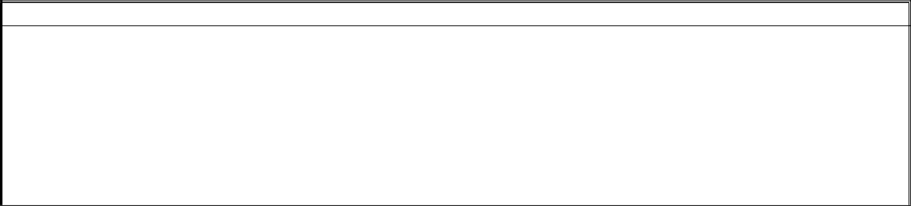

**PHASE II: MANDATORY WATER USE REDUCTION MEASURES FOR NEWTON**

**TRIGGERS**

A reduction in the flow of the Jacobs Fork River at the raw water intake to 8 million gallons per day (MGD) for a period of seven (7) consecutive days;

Or greater than 80% of the river flow is being used for 7 consecutive days; Or any combinations of the above conditions for 7 consecutive days;

Or failure of Phase I measures to result in a reduction of potable water-use demand;

The Mayor may declare the Phase II reductions prior to the 7th day of the conditions above if it is determined to be necessary.

|  |
| --- |
| **RESPONSE**  The Mayor shall declare a **Water Shortage Alert**;  All voluntary measures become mandatory in addition to the following measures:  Enforce a system-wide 25% water use reduction goal (including industrial and commercial plans); Notify water use customers by any or all methods as previously outlined;  Limit all landscape irrigation to one day per week using drip irrigation or hand held nozzle; Limit residential outdoor watering to spray nozzle or drip irrigation only;  Ban all non-commercial car washing;  All vehicle sales dealerships limited to wash vehicle only upon buying or sale of vehicle; Ban all non-commercial pressure washing and washdown of impervious surfaces; Restaurants allowed to serve water only upon request;  Ban the filling of newly constructed or recently drained pools unless to prevent damage; Public recreational areas are limited to watering on Monday between the hours of 6pm-8am; Institutional automatic toilet flushing systems will operate only during business hours;  All non-public hydrant use permits evaluated and approved only for health & safety reasons; Ban ornamental uses;  Develop water rationing plan;  Develop daily household consumption restrictions;  Mayor may authorize additional water use restrictions or bans to be enforced 10 days after public notification. |

# PHASE III: EMERGENCY WATER USE REDUCTION MEASURES FOR NEWTON

|  |
| --- |
| **TRIGGERS** |
| A reduction in the flow of the Jacobs Fork River at the raw water intake to 6 million gallons per day (MGD) for a period of seven (7) consecutive days;  Or greater than 90% of the river flow is being used for 7 consecutive days; Or any combinations of the above conditions for 7 consecutive days.  Or failure of Phase II measures to result in a 25% reduction of potable water-use demand.  The Mayor may declare the Phase III reductions prior to the 7th day of the conditions above if it is determined to be necessary. |
| **RESPONSE** |
| The Mayor shall declare a **Water Shortage Emergency**;  In addition to the above measures the following measures will also be imposed: Notify water use customers by any or all methods as previously outlined;  Ban all Class III non-essential use except as follows:  Ban all landscape irrigation (including golf course greens, school grounds, residential lawns); Ban vehicle washing by vehicle sales dealerships;  Ban all non-public hydrant use;  Implement daily household consumption restrictions; Ban topping off pools;  Request additional conservation from Class 1 (essential) users as may be possible; Consider enacting advanced restriction pricing and/or surcharge with fines for overuse;  Limit garden irrigation to two days per week between 6pm to 8am by hand or drip irrigation only; Ban all recreational use.  Mayor may authorize additional water use restrictions or bans to be enforced 10 days after public notification. |

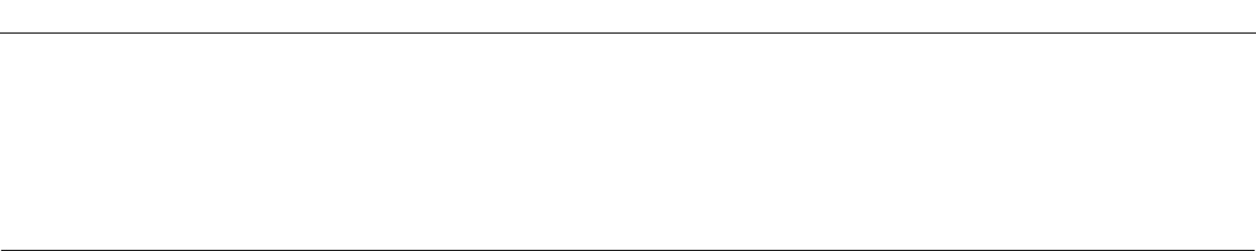

**PHASE IV: CRISIS WATER USE REDUCTION MEASURES FOR NEWTON**

|  |
| --- |
|  |
| **RESPONSE** |
| The Mayor shall declare a **Water Shortage Crisis**;  In addition to the above measures the following measures will also be imposed: Notify water use customers by any or all methods as previously outlined;  Ban all garden irrigation  Flow to wholesale water customers will be reduced or eliminated as needed to meet demand; Require additional conservation from Class 1 (essential) users as may be possible; Reevaluate and consider additional advanced restriction pricing with fines for overuse; Implement water rationing plan;  Implement daily household consumption restrictions.  All industrial and other large users required to follow Large Water User Restriction Guidelines set by the City. Mayor may authorize additional water use restrictions or bans to be enforced 10 days after public notification.  . |

**VI: ENFORCEMENT**

The provisions of the water shortage response plan will be enforced by The City of Newton Utility Department and Police Personnel. Violators may be reported to the City’s Dedicated Water Conservation Hotline. Citations are assessed according to the following schedule depending on the number of prior violations and current level of water shortage.

|  |  |  |  |
| --- | --- | --- | --- |
| **OFFENSE** | **Phase I: VOLUNTARY** | **Phase II: MANDATORY** | **Phase III: EMERGENCY** |
| FIRST | Notice of Violation (NOV) | NOV and warning | $50 Fine |
| SECOND | NOV | $50 Fine | $100 Fine |
| THIRD | NOV | $100 Fine | $250 Fine |
| FOURTH | NOV | $250 Fine | $350 Fine |
| MORE THAN FOUR  OFFENSES | NOV | Water Service Disconnection  + Associated Reconnect Fees | Water Service Disconnection  + Associated Reconnect Fees |

# Phase IV enforcement penalties will be double the Phase III penalties.

1. **RETURN TO NORMAL OPERATIONS IN NEWTON**

Phase conservation measures and restrictions will expire incrementally when the Mayor, after consultation with the City manager and Utility Director, finds that the water supply has returned to normal.

# PUBLICE COMMENT

Any proposed amendment to the City of Newton’s Water Shortage Response Plan shall be presented to the City Council to set a date for a Public Hearing and received comments over a 30-day period prior to the public hearing. During this comment period staff will contact all of those residents of Newton who comment on the plan and resolve any issues with the plan. Once this period is concluded staff will present the recommended plan to the Council for adoption.

# IX.VARIANCE PROTOCOLS

No variances will be approved. X.**EFFECTIVENESS**

Water savings will be determined by data from water meter consumption totals. This data will then be evaluated

against previous year’s seasonal data along with expected water usage to determine if water savings are being obtained.

# XI.PLAN REVISIONS

The Public Works Director will review the plan on a yearly basis to determine if any revisions need to be made due to changing circumstances. When there are significant changes that will require the plan to be revised they will recommend a revision to the City Manager. The City Manager will then present these revisions to the Council to set a date to hold a public hearing to adopt the proposed revisions after the 30-day public comment period.