CHAPTER 51: GENERAL WATER AND SEWER REGULATIONS

Updated March 2023

Section

Water Shortage Response

  - Authorization
  - Notification
  - Levels of response
  - Triggers
  - Return to normal
  - Enforcement
  - Public comment
  - Variance protocols
  - Effectiveness
51.10 Revision

Water and Sewer Services

  - Applicability to service contracts
  - Connections required
  - Mobile homes
  - Connection applications and permits
  - Connection requirements
  - Cut off of water supply
  - Taps into water or sewer lines
  - Tampering with meters or lines
  - Service rates and charges
  - Billings and rates
  - Connections outside of town
  - Tap fee
  - Town equipment
  - Installation costs
  - Deposit
  - Meters; generally

51. 99 Penalty

Cross-reference:
Disposal of sewage and garbage regulated, see § 50 .02 Land Usage, see Title XV
Use of Sewer System, see Ch. 52

7

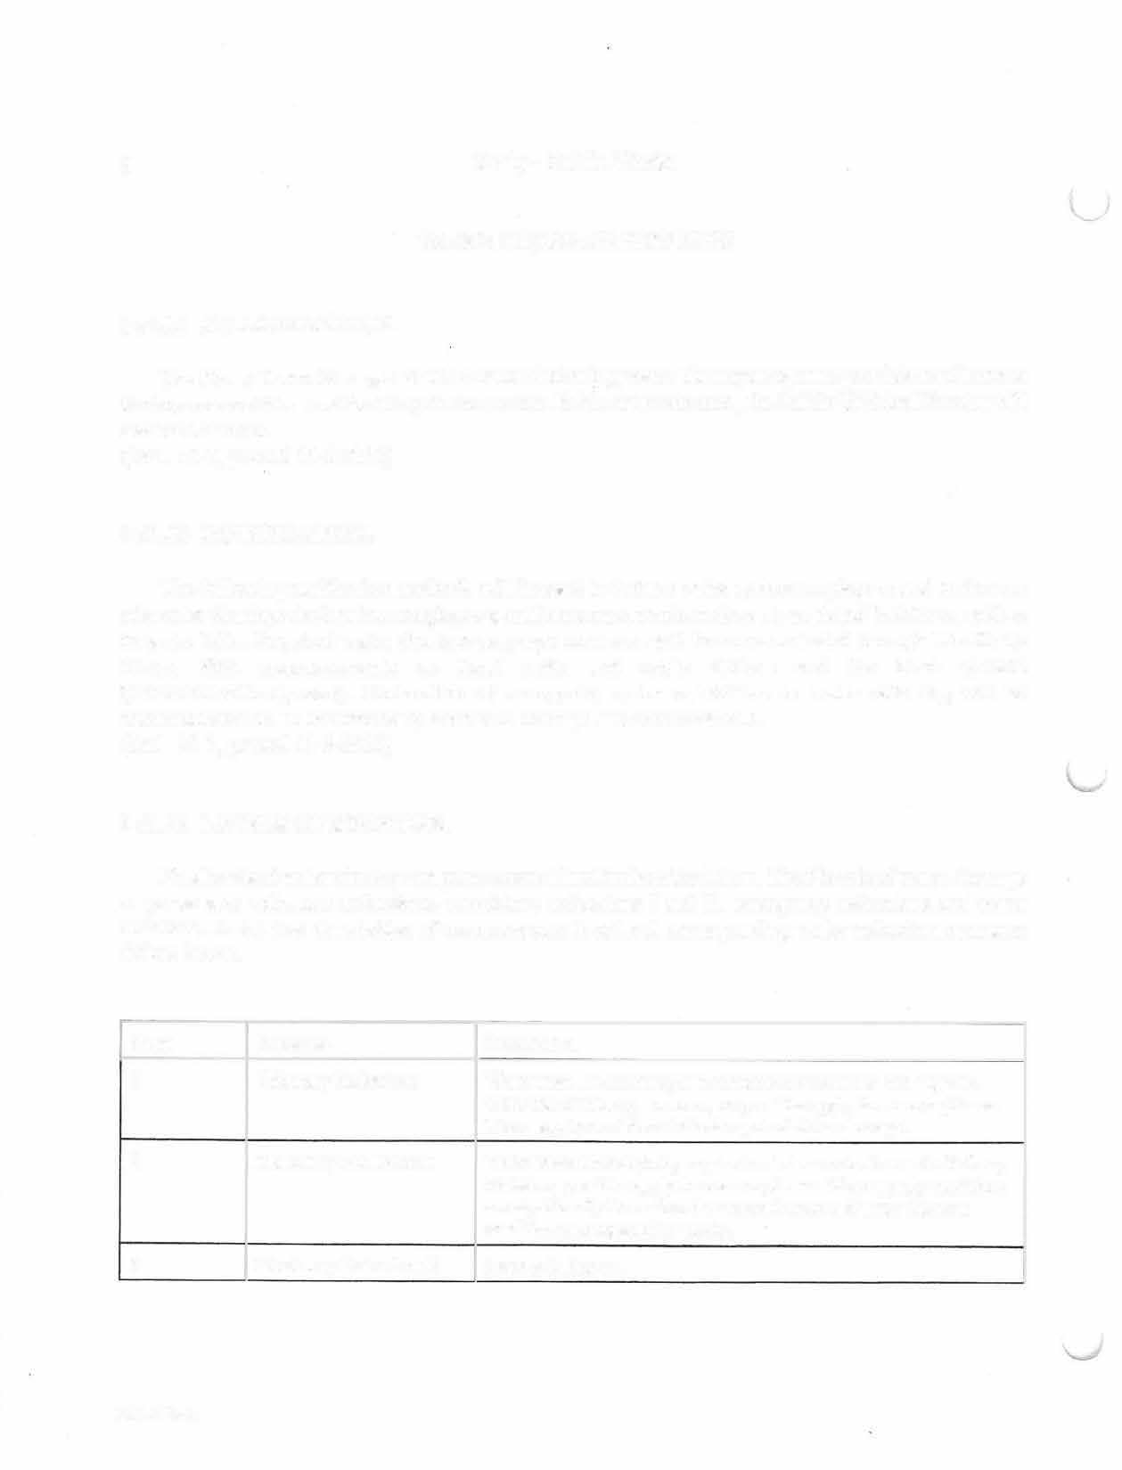
8 Kenly - Public Works

. WATER SHORTAGE RESPONSE

§ 51.01 AUTHORIZATION.
The Kenly Town Manager shall enact the following water shortage response provisions whenever the trigger conditions outlined in § 51. 04 are met. In his or her absence, the Town Clerk will assume this role. (Ord. 10-7, passed 11-8-2010)

Herbert L. Hales Tymeeka Williams, Town Clerk
(919) 286-2116 (919) 286-2116
tooiehalespe@gmail.com tymeeka.williams@townofkenly.com

§ 51.02 NOTIFICATION.
The following notification methods will be used to inform water system employees and customers of a water shortage declaration: employee e-mail announcements, notices at municipal buildings, notices in water bills. Required water shortage response measures will be communicated through The Kenly News, PSA announcements on local radio and cable stations and the town website (www.townofkenly.com). Declaration of emergency water restrictions or water rationing will be communicated to all customers by telephone through use of reverse 911. (Ord. 10-7, passed 11-8-2010)

§ 51.03 LEVELS OF RESPONSE.
Five levels of water shortage response are outlined in the table below. The 5 levels of water shortage response are: voluntary reductions, mandatory reductions I and II, emergency reductions and water rationing. A detailed description of each response level and corresponding water reduction measures follow below.
Stage | Response | Description
1  2  3 | Voluntary Reductions  Mandatory Reductions I  Mandatory Reductions II | Water users are encouraged to reduce their water use and improve water use efficiency; however, no penalties apply for noncompliance. Water supply conditions indicate a potential for shortage.  Water users must abide by required water use reduction and efficiency measures; penalties apply for noncompliance. Water supply conditions are significantly lower than the seasonal norm and water shortage conditions are expected to persist.  Same as in Stage 2
2014 S-2

Stage | Response | Description
4 | Emergency Reductions | Water supply conditions are substantially diminished and pose an imminent threat to human health or environmental integrity.
5 | Water Rationing | Water supply conditions are substantially diminished and remaining supplies must be allocated to preserve human health and environmental integrity.

- In Stage 1, Voluntary Reductions, all water users will be asked to reduce their normal water use by 5%. Customer education and outreach programs will encourage water conservation and efficiency measures including: irrigating landscapes a maximum of 1 inch per week; preventing water waste, runoff and watering impervious surfaces; watering plants deeply to encourage root growth; washing only full loads in clothes and dishwashers; using spring-loaded nozzles on garden hoses; and identifying and repairing all water leaks.

- In Stage 2, Mandatory Reductions I, all customers are expected to reduce their water use by 10% in comparison to their previous month's water bill, in addition to continuing to encourage all voluntary reduction actions, the following restrictions apply: irrigation is limited to a half inch per week between 8PM and 8AM; outdoor use of drinking water for washing impervious surfaces is prohibited; and all testing and training purposes requiring drinking water (e.g. fire protection) will be limited.

- In Stage 3, Mandatory Reductions Il, customers must continue actions from all previous stages and further reduce water use by 20 % compared to their previous month's water bill. All non-essential uses of drinking water are banned and garden and landscape irrigation must be reduced to the minimum amount necessary for survival. Additionally, in Stage 3, a drought surcharge of 1.5 times the normal water rate applies.

- In Stage 4, Emergency Reductions, customers must continue all actions from previous stages and further reduce their water use by 25% compared to their previous month's water bill. A ban on all use of drinking water except to protect public health and safety is implemented and drought surcharges increase to 2 times the normal water rate.

- The goal of Stage 5, Water Rationing, is to provide drinking water to protect public health (e.g. residences, residential health care facilities and correctional facilities). In Stage 5, all customers are only permitted to use water at the minimum required for public health protection. Firefighting is the only allowable outdoor water use and pickup locations for distributing potable water will be announced according to Kenly's Emergency Response Plan. Drought surcharges increase to 5 times the normal water rate. (Ord. 10-7, passed 11-8-2010)

§ 51.04 TRIGGERS.

Kenly is provided water by purchase from Johnston and Wilson Counties. The town purchases water monthly from Johnston County and typically only accesses Wilson County's supply during an emergency. When Johnston County declares a water shortage Kenly is required to do so as well. During this time, the Kenly Public Utilities Director will stay in close contact with Johnston County and follow their Water Shortage Response Levels.
(Ord. 10-7, passed 11-8-2010)

§ 51.05 RETURN TO NORMAL.

When water shortage conditions have abated and the situation is returning to normal, water conservation measures employed during each phase should be decreased in reverse order of implementation.
(Ord. 10-7, passed 11-8-2010)

§ 51.06 ENFORCEMENT.

- The provisions of the water shortage response plan will be enforced by Town of Kenly Public Utilities Department and police personnel. Violators may be reported by phone, email or in-person at Town Hall. Citations are assessed according to the following schedule depending on the number of prior violations and current level of water shortage.

Water Shortage Level | First Violation | Second Violation | Third Violation
Voluntary Reductions | NIA | NIA | NIA
Mandatory Reductions (Stages 2 and 3) | Warning | $250 | Discontinuation of Service
Emergency Reductions | $250 | Discontinuation of Service | Discontinuation of Service
Water Rationing | $500 | Discontinuation of Service | Discontinuation of Service

- Drought surcharge rates are effective in Stages 3, 4 and 5 (Ord. 10-7, passed 11-8-2010)

§ 51.07 PUBLIC COMMENT.

Customers will have multiple opportunities to comment on the provisions of the water shortage
response plan. This plan will be available at Town Hall. A notice will be

included in the customer water bill notifying them of such.

§ 51.08 VARIANCE PROTOCOLS.

Applications for water use variance requests are available from the Town Public Works Office. All applications must be submitted to the Public Works Office for review by the Public Works Director or his or her designee. A decision to approve or deny individual variance requests will be determined within 2 weeks of submittal after careful consideration of the following criteria: impact on water demand, expected duration, alternative source options, social and economic importance, purpose (i.e. necessary use of drinking water) and the prevention of structural damage (Ord. 10-7, passed 11-8-2010)

§ 51.09 EFFECTIVENESS.

The effectiveness of the Kenly water shortage response plan will be determined by comparing the stated water conservation goals with observed water use reduction data. Other factors to be considered include frequency of plan activation, any problem periods without activation, total number of violation citations, desired reductions attained and evaluation of demand reductions compared to the previous year's seasonal data (Ord. 10-7, passed 11-8-2010)

§ 51.10 REVISION.

The water shortage response plan will be reviewed and revised as needed to adapt to new circumstances affecting water supply and demand, following implementation of emergency restrictions, and at a minimum of every 5 years in conjunction with the updating of our Local Water Supply Plan. Further, a water shortage response planning work group will review procedures following each emergency or rationing stage to recommend any necessary improvements to the plan to the Kenly Town Council (Ord. 10-7, passed 11-8-2010). The Town Manager is responsible for Plan review/revision.

''--"

WATER AND SEWER SERVICES

§ 51.20 APPLICABILITY TO SERVICE CONTRACTS.

All pertinent provisions of§§ 51.20 et seq. are hereby made a part of the terms and conditions of any contract whereby the Town of Kenly furnishes sewer service or water service to any individual or corporate entity or other association or performs any work of any kind in connection with the furnishing of a sewer service or water service.
(Ord. 51, passed 5-7-1979)

§ 51.21 CONNECTIONS REQUIRED.

Every house, building, apartment, or other residential, institutional, or business building abutting any water and sewer main in the Town of Kenly shall be separately and independently connected to the water and sewer main.
(Ord. 51, passed 5-7-1979) Penalty, see§ 51.99

§ 51.22 MOBILE HOMES.
·-
Sections 51.20 et seq. shall apply to mobile home or mobile building owners and occupiers and to the lots on which the mobile homes or mobile buildings may be located in the same manner as the same applies to permanent construction buildings.
(Ord. 51, passed 5-7-1979)

§ 51.23 CONNECTION APPLICATIONS AND PERMITS.

(A) Any individual or corporate entity or other association wishing to connect with the water system of the Town of Kenly shall first file written application with the Town Clerk, and the approval of the application shall be in the form of a permit. All applications pending at the time§§ 51.20 et seq. shall become effective and all future applications shall be subject to the rates in existence at the time the applications may be approved and permits issued. In addition, the applicant shall, by filing the application, agree to be governed by the rules and regulations of the town, to give 10-days' notice in case he or she shall desire to stop using town water, to be responsible for water charges in case the notice shall not be given and to waive all right of action against the town in case the Town Council shall find necessary to cut off the property owner's or user's water supply.
(Ord. 51, passed 5-7-1979)

