**Water Shortage Response Plan (WSRP)**

**Town of Sparta, North Carolina**

**PWSID: 01-03-010**

**December 2018**

**Revised March 2023**

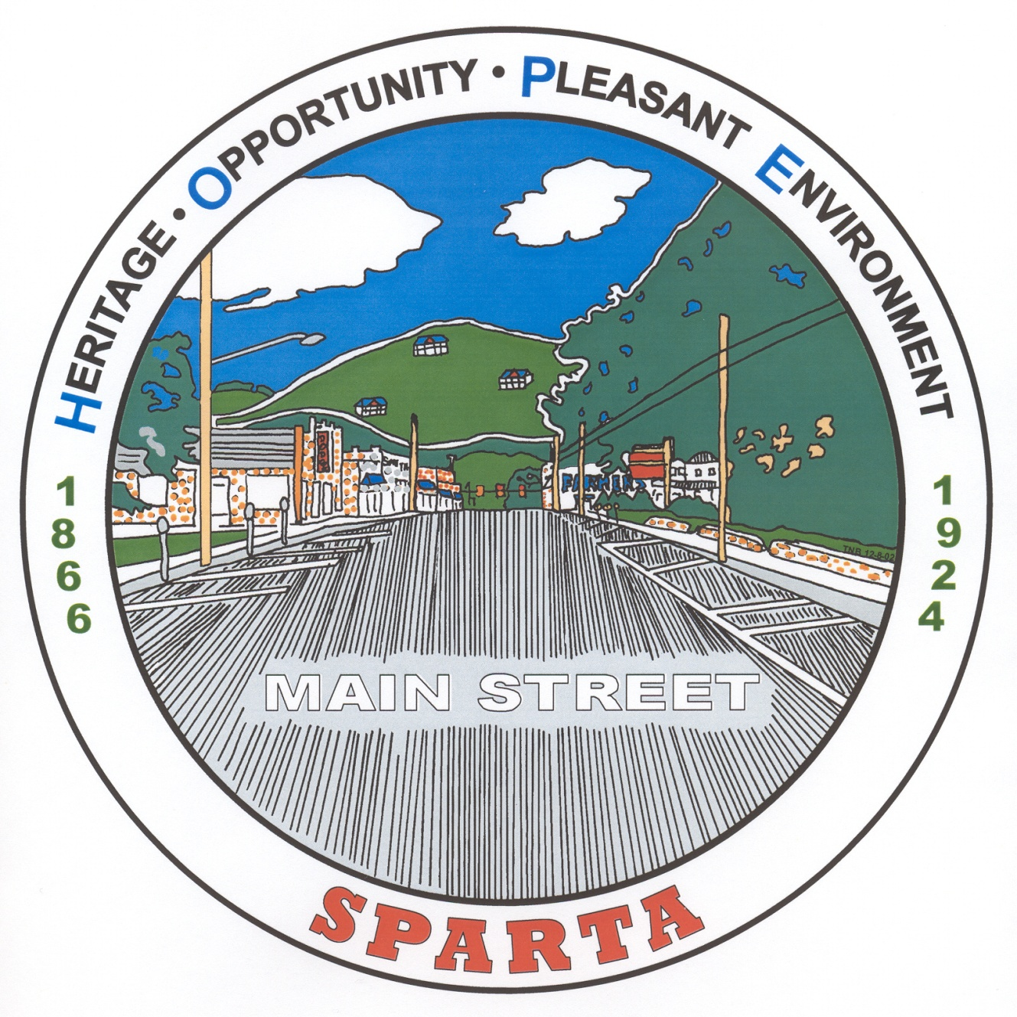

1. **WATER SHORTAGE RESPONSE PLAN PROCEDURE**

All users purchasing water from the Town of Sparta Water System will, at a minimum, implement and enforce water use conservation measures contained in this plan as a stipulation of water sales. When the benchmarks established in Section IV of this plan are reached, the Town Manager is authorized to declare a water shortage and enact the provisions of the Plan. In the absence of the Town Manager, the Public Works Director will enact the Plan. Upon the announcement of a water shortage a press release will be forwarded to the following media outlets: LOCAL NEWSPAPER, AND LOCAL RADIO STATION.

Ryan Wilmoth, Manager Kevin Dowell, Public Services Director

336-372-4257 336-372-4257

[spartamgrwilmoth@skybest.com](mailto:spartamgrwilmoth@skybest.com) [kdowell@townofsparta.org](mailto:kdowell@townofsparta.org)

1. **YEAR-ROUND WATER CONSERVATION POLICY**

The Town of Sparta Mayor and Council members encourages all municipality supplied water users to make efficient and responsible use of water at all times.

The Town Manager will keep in close contact with the Water Supervisor for updates regarding water use and drought conditions. When impending drought conditions arise the Town Manager will increase monitoring of the water use respective to plant capacity and available raw water supplies. Weekly reports will be kept until conditions return to a standard level.

**Public Education and Outreach Consists of the Following Activities**

* Independent Mailings to Major Users
* Newspaper Ads
* Radio Announcements
* Water Audits
* Bill Stuffers to all customers
* Signs and Posters

1. **WATER USE CLASSIFICATION**

To aid in the realization of this Water Shortage Response Plan the following water classifications have been established.

**CLASS I: ESSENTIAL POTABLE WATER USES**

**Domestic –** Water to sustain human and domestic pet life; maintain minimum standards of hygiene and Sanitation.

**Patient Care –** Patient Care and Rehabilitation.

**Public Use –** Firefighting and approved flushing of hydrants to ensure public health and safety

**CLASS II: SOCIALLY/ECONOMICALLY IMPORTANT POTABLE WATER USES**

**Domestic –** Minimal use for kitchen, bathroom, and laundry; Minimal watering of vegetable gardens and

Trees to maintain them.

**Commercial –** Commercial vehicle washes and Laundromats, restaurants and hotels, irrigation of commercial nurseries at a minimum level, minimum amount required to maintain essential cooling operations.

**Agricultural –** Minimum amount required maintaining crop livelihood, livestock, and related activities.

**Industrial –** Minimum use necessary to operate production facilities and maintain jobs.

**Institutional –** Efficient use by schools, churches, government facilities, and other institutional users.

**CLASS III: NON ESSENTIAL POTABLE WATER USES**

**All –** Ornamental uses (fountains, reflecting pools, artificial waterfalls, etc.); Residential lawn irrigation; Non-commercial washing of vehicles; Wash down of impervious surfaces.

**Public Use –** Gardens, Lawns, Parks, Golf Courses, playing fields and recreational areas.

**Commercial –** Serving water in restaurants except by request.

1. **DROUGHT RESPONSE TRIGGERS AND PHASED WATER USE REDUCTIONS**

When the following water supply thresholds (Triggers) are reached, the Town Manager shall initiate the following conservation Stages.

**Stage I: Voluntary Water Use Reduction**

**Triggers:**

A 20% reduction in the seasonal normal distance between the static water level in the well and the pump intake; Or greater than 80% of the system’s capacity is being used for 5 consecutive days within a 30 day period.

**RESPONSE:**

Begin the circulation of water use reduction education materials;

The Town Manager shall declare a **Water Shortage Advisory**;

Request voluntary conservation as outlined in the distributed educational materials;

Request Class-III non essential water uses to be reevaluated and conserved.

**Stage II: Mandatory Water Use Reduction Measures**

**Triggers:**

A 40% reduction in the seasonal normal distance between the static water level in the well and the pump intake; Or greater than 90% of the system’s capacity is being used for 3 consecutive days within a 30 day period. Or any combination of the above conditions for 3 consecutive days within a 30 day period, or failure of Stage I measures to result in a reduction of potable water-use demand.

**RESPONSE:**

The Town Manager shall declare a **Water Shortage Alert**;

In addition to the previous measures the following may also be imposed:

All voluntary measures become mandatory in addition to the following measures;

Enforce a system-wide 15% reduction water use reduction goal;

Notify water use customers by any or all methods as previously mentioned;

Ban all no-commercial pressure washing and Wash down of impervious surfaces;

Ban ornamental uses;

Town Manager may choose to carry out additional water use restrictions and or bans to be enforced 7 days after public notification.

**Stage III: Emergency Water Use Reduction Measures**

**Triggers:**

A 60% reduction in the seasonal normal distance between the static water level in the well and the pump intake; Or greater than 95% of the system’s capacity is being used for 2 consecutive days within a 30 day period; Or any combination of the above for 2 consecutive days; Or failure of Phase II measures to result in a 25% reduction of potable water-use demand.

**RESPONSE:**

The Town Manager shall declare a **Water Shortage Emergency**;

In addition to the previous measures the following may also be imposed:

Enforce a system-wide 20% reduction water use reduction goal;

Notify water users by any and all methods previously outlined;

Ban Class-III non –essential uses;

Request additional conservation from Class I (essential) users as may be possible;

Ban all landscaping irrigation (including school grounds, residential lawns, etc.);

Ban all recreational use;

Town Manager may choose to carry out additional water use restrictions and or bans to be enforced 3 days after public notification.

**Movement from more and less restrictive levels**

As the above determining parameters decrease in severity and return to acceptable levels, the Town Manager

will lift the Water Shortage Response Plan. The cancellation procedure will be in the reverse order of the Water Shortage Response Plan implementation procedure.

1. **COMPLIANCE AND ENFORCEMENT.**

Compliance with the provisions of this Plan shall be enforced by personnel of the Utilities Department, the Town of Sparta Police Department and other such personnel as designated by the Town Manager. Failure to comply with any of the regulations of these sections shall be unlawful and a violation of the Plan, and all remedies authorized by law for noncompliance with this Plan, including the issuance of a civil citation as hereinafter set forth or action for injunctive relief, may be exercised to enforce its provisions. It shall be unlawful to fail to act in accordance herewith to use water in any illegal manner or attempt to evade or avoid such water restrictions.

**TOWN OF SPARTA ENFORCEMENT PENALTIES**

|  |  |  |  |
| --- | --- | --- | --- |
| **OFFENSE** | **PHASE I: VOLUNTARY** | **PHASE II: MANDATORY** | **PHASE III: EMERGENCY** |
| FIRST | None | Notice of Violation (NOV) | NOV and $ 50 fine |
| SECOND | None | NOV and $ 50 fine | NOV and $ 100 fine |
| THIRD | None | NOV and $ 100 fine | Service Disconnection & Associated Reconnect Fee |
| MORE THAN 3  OFFENSES | None | Service Disconnection and Associated Reconnect Fee | Service Disconnection & Associated Reconnect Fee |

1. **RESIDENTIAL AND NON-RESIDENTIAL CONSERVATION RATES**

|  |  |
| --- | --- |
| **Water System Operating Condition** | **Conservation Rates** |
| Normal Conditions / Water Shortage Advisory | Normal Conservation Measures |
| Water Shortage Alert | Increased Conservation Measures |
| Water Shortage Emergency | Increased Conservation Measures |

1. **RETURN TO NORMAL OPERTATING CONDITIONS**

Conservation measures will conclude after the Supervisor of the Water Department has contacted the Town Manager and advised that the water use, and /or conditions have improved to a level that safely allows the return to a less restrictive conservation stage or back to normal altogether.

1. **PUBLIC COMMENT**

Customers will have the opportunity to comment on the provisions of the Water Shortage Response Plan. A draft of the plan will be posted on the Town of Sparta’s website and at the Town Hall. A public hearing will be scheduled with notice printed in the Alleghany News at least 14 days prior to the date of public hearing and adoption of the plan to solicit public comment on the draft.

1. **VARIANCE PROTOCOLS**

Variance requests must be made in writing and must be submitted in person to the Town Hall for review by the Town Manager and the Supervisor of the Water Department. A decision to approve or deny individual variance requests will be determined within 7 days of submittal after careful consideration of the following criteria: impact on water demand, expected duration, alternative source options, social and economic importance, purpose (i.e. necessary use of drinking water) and the prevention of structural damage.

1. **EFFECTIVENESS**

The effectiveness of the Town of Sparta’s Water Shortage Response Plan will be determined by comparing the stated water conservation goals with observed water used reduction data. Other factors to be considered include frequency of plan activation, any problem periods without activation, total number of violation citations, desired reductions attained and evaluation of demand reductions compared to the previous year’s seasonal data.

1. **REVISION**

The Water Shortage Response Plan will be reviewed and revised as needed to adapt to new circumstances affecting water supply and demand, following implementation of emergency restrictions, and at a minimum of every five years.